Name:
Student ID:
Class:

OS
LAB 1

CHECKLIST
1. Homework
 | 1 | 2 | 3 | 4 | 5 | 6
Explanation
Your code
Results and discussions

Mark:

*Notice: Export PDF file, name format:
<MSSV>_LAB1.pdf
2. Lab 1 Execute, google, and explain usage of all commands in this section
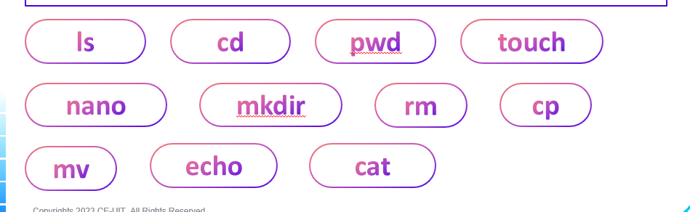
Answer:

2. Create a folder tree like image below:
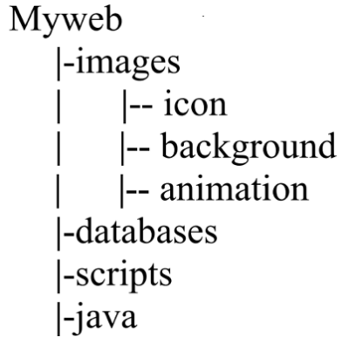
Answer:
3. Google how to find files with the “.html” extension in your entire system. Copy one of them to Myweb.
Answer:

4. Remove the directory Myweb/scripts.
Answer:

5. Set the permission for Myweb/databases as below:
- The owner has all permissions
- Other users have no permission
Answer:

